# CS 123 Midterm Review

### **First reference book: Chapters 1,2,3**

### **Second reference book: Chapters 1,2,3**

1. Introduction

**Hardware:**

* CPU, Memory
* I/O devices
* Secondary storage devices

### **Software:**

* Operating Systems
* User Applications

### **Programming Languages**

* Machine languages
* Assembly languages
* High-level programming languages (C, C++, C#, Java, Perl, Python, Ruby, BASIC)
* Compiler/Interpreter: difference between them
* Why Java? Being used for various types of applications
* Characteristics of Java:
* Compile and run Java program: Java source code -> Java Byte code -> JVM
* Components of Java source code:
  + - Class, main method
    - Statement
    - Reserved words
* Special symbols of Java:
  + - ;
    - {}
    - ()
    - //
    - /* */
    - “”
* Java Errors:
* Syntax errors
* Semantics errors
* Runtime errors

## Java Fundamentals

## 

* Class
* Main method
* Indentation
* Keywords (reserved words), e.g., class, public, double, etc.
* Displaying messages:
* System.out.println()
* System.out.print()
* Variables
* Definition
* Declaring variable (the syntax)  
  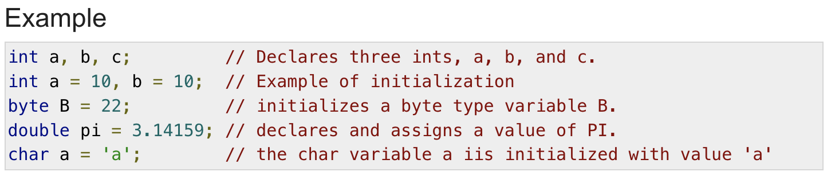
* Declare before using the variable
* Variable initialization using assignment operator
  + Name:
    - Descriptive
    - Case sensitive
    - No space
    - Avoid keywords
* Primitive datatypes:
* byte (1 byte)
* short (2 bytes)
* int (4 bytes)
* long (8 bytes)
* float (4 bytes)
* double (8 bytes)
* char (2 bytes)
* boolean (1 bit)
* Concatenation operator (+): if either operand of it is a string, the result is a string.
* Assignment operator (=): e.g., x=5.77;
* Mathematical operators:
  + +
  + -
  + *
  + /
  + %
* Division can yield different results
* Division of two ints will yield an int, division with at least one double will yield a double  
  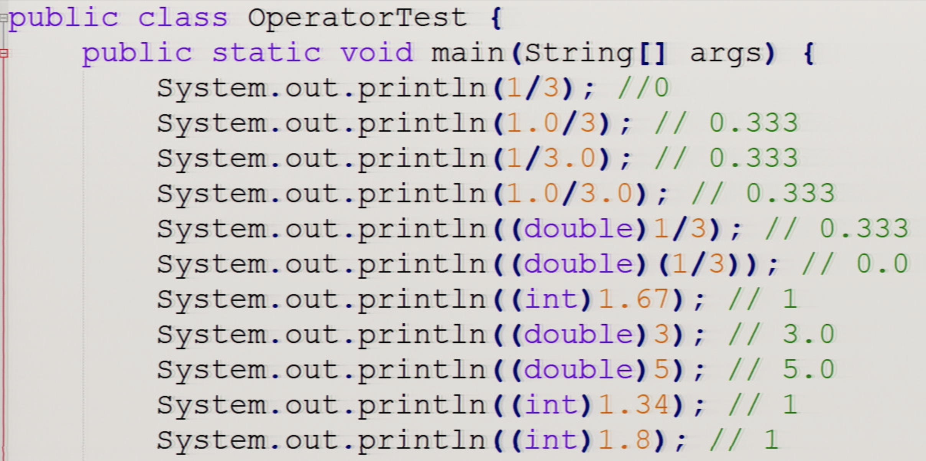  
  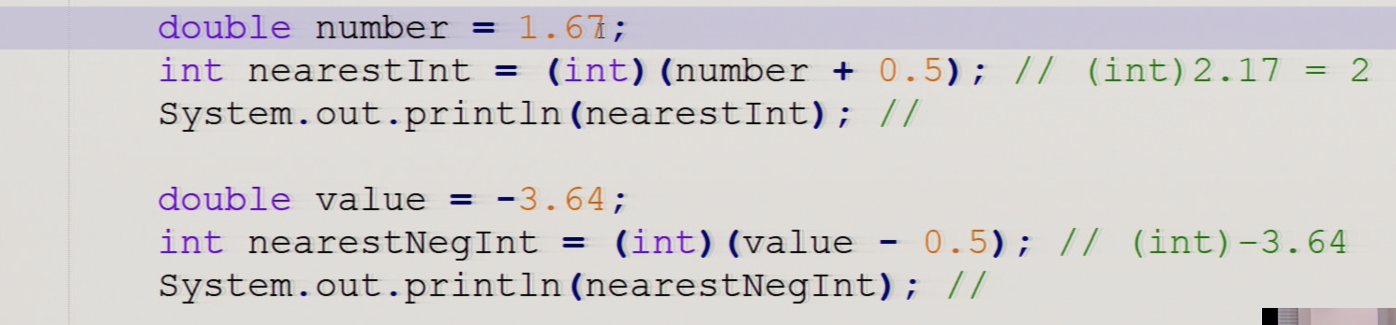
* Modulo (e.g., 5 % 2 = 1)
* Operator Precedence

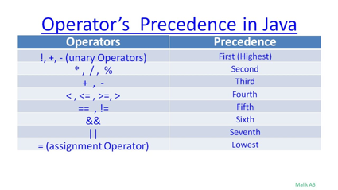

* Operators with the same precedence are evaluated, then they are evaluated from left to right
* Reading keyboard input using Scanner object:
* Syntax

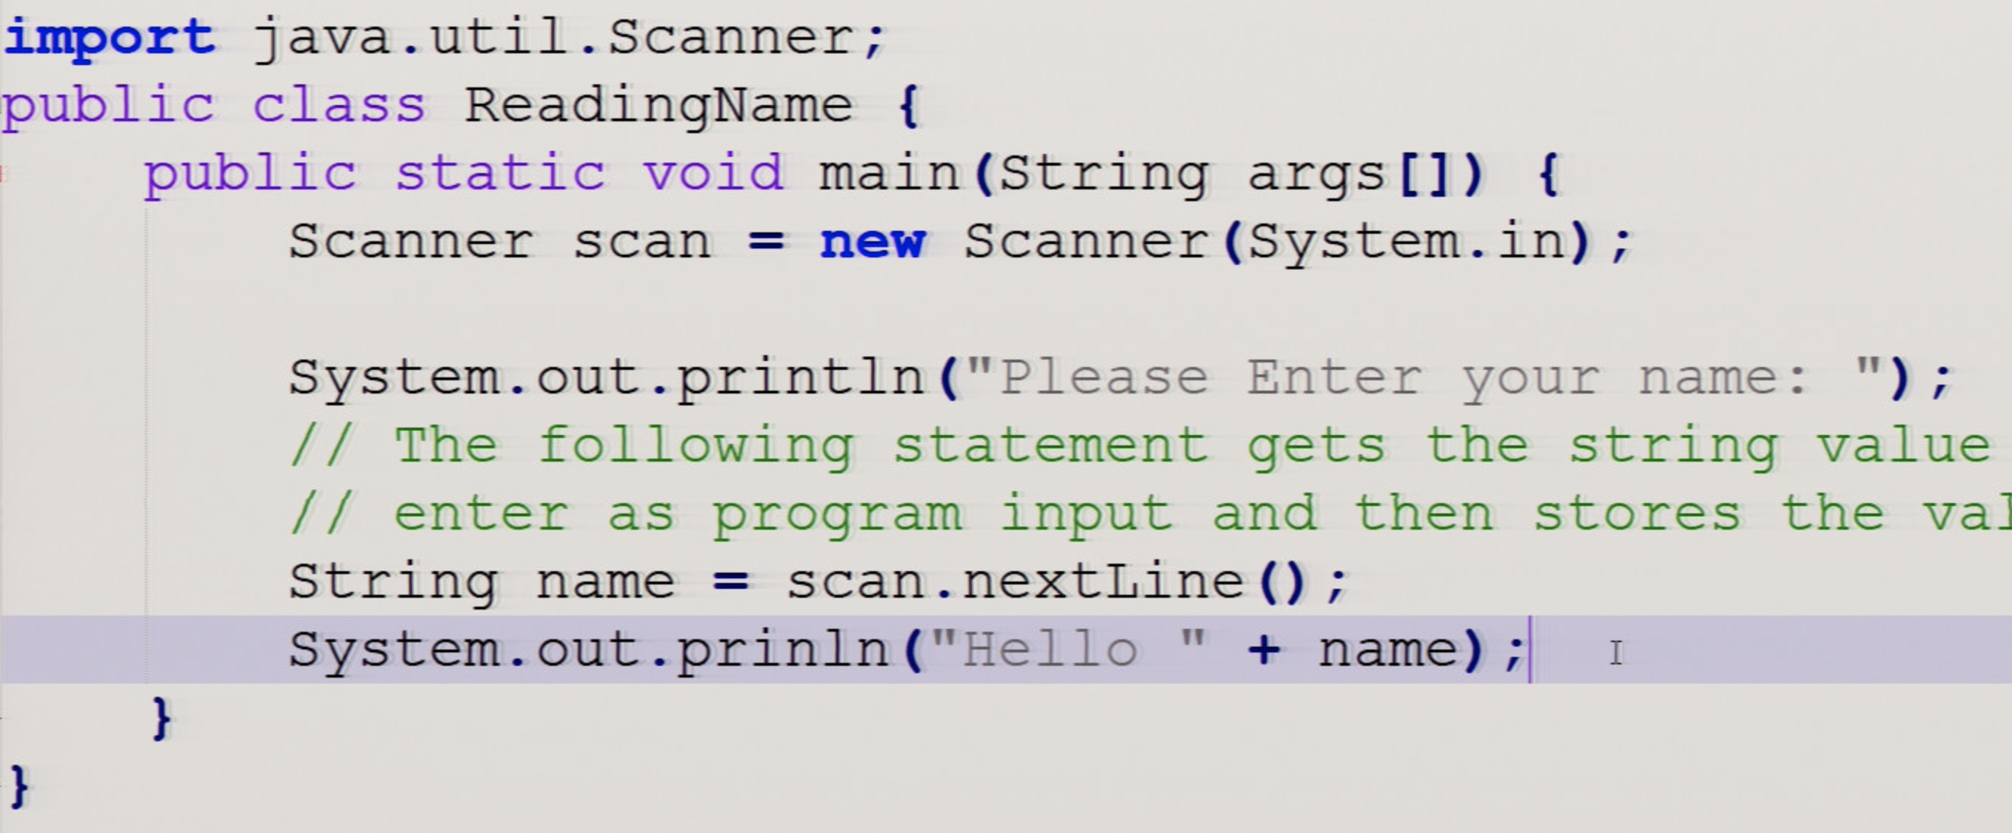

* Variable methods, e.g., nextInt(), nextDouble(), etc.

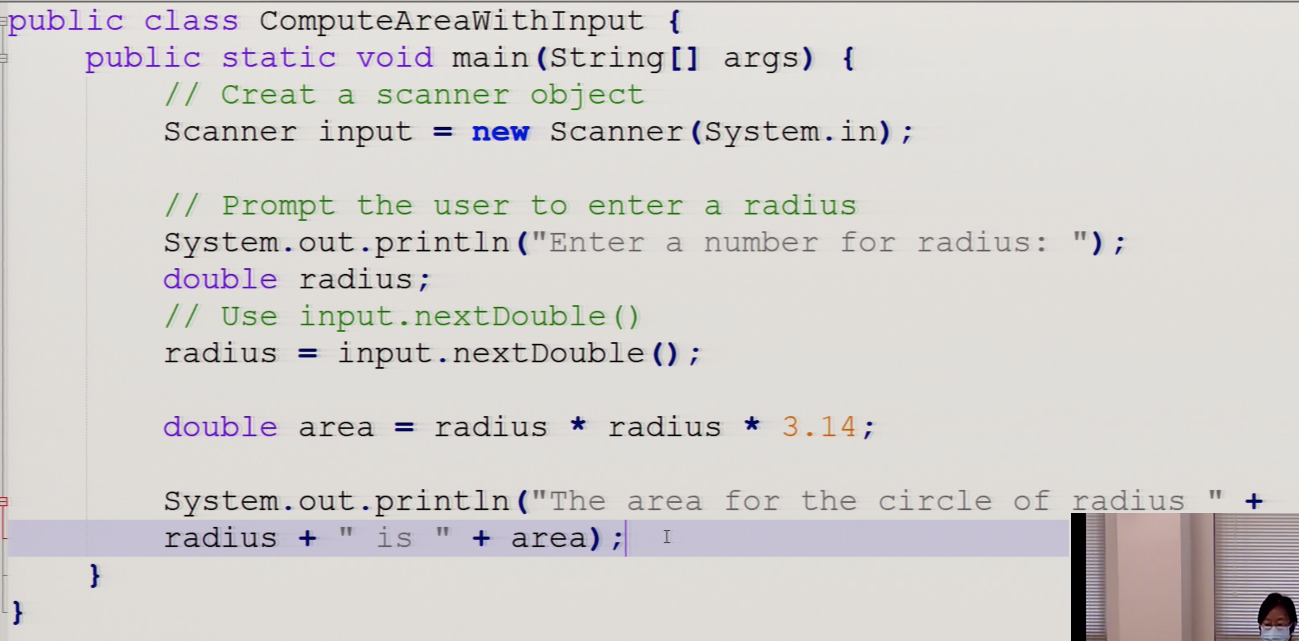

* Casting variables:
* (int)
* (double)

## Selections

### **Boolean Expressions**

* Boolean Values: True/False
* Boolean Expression: is a combination of operators and operands that returns a value of Boolean.  
  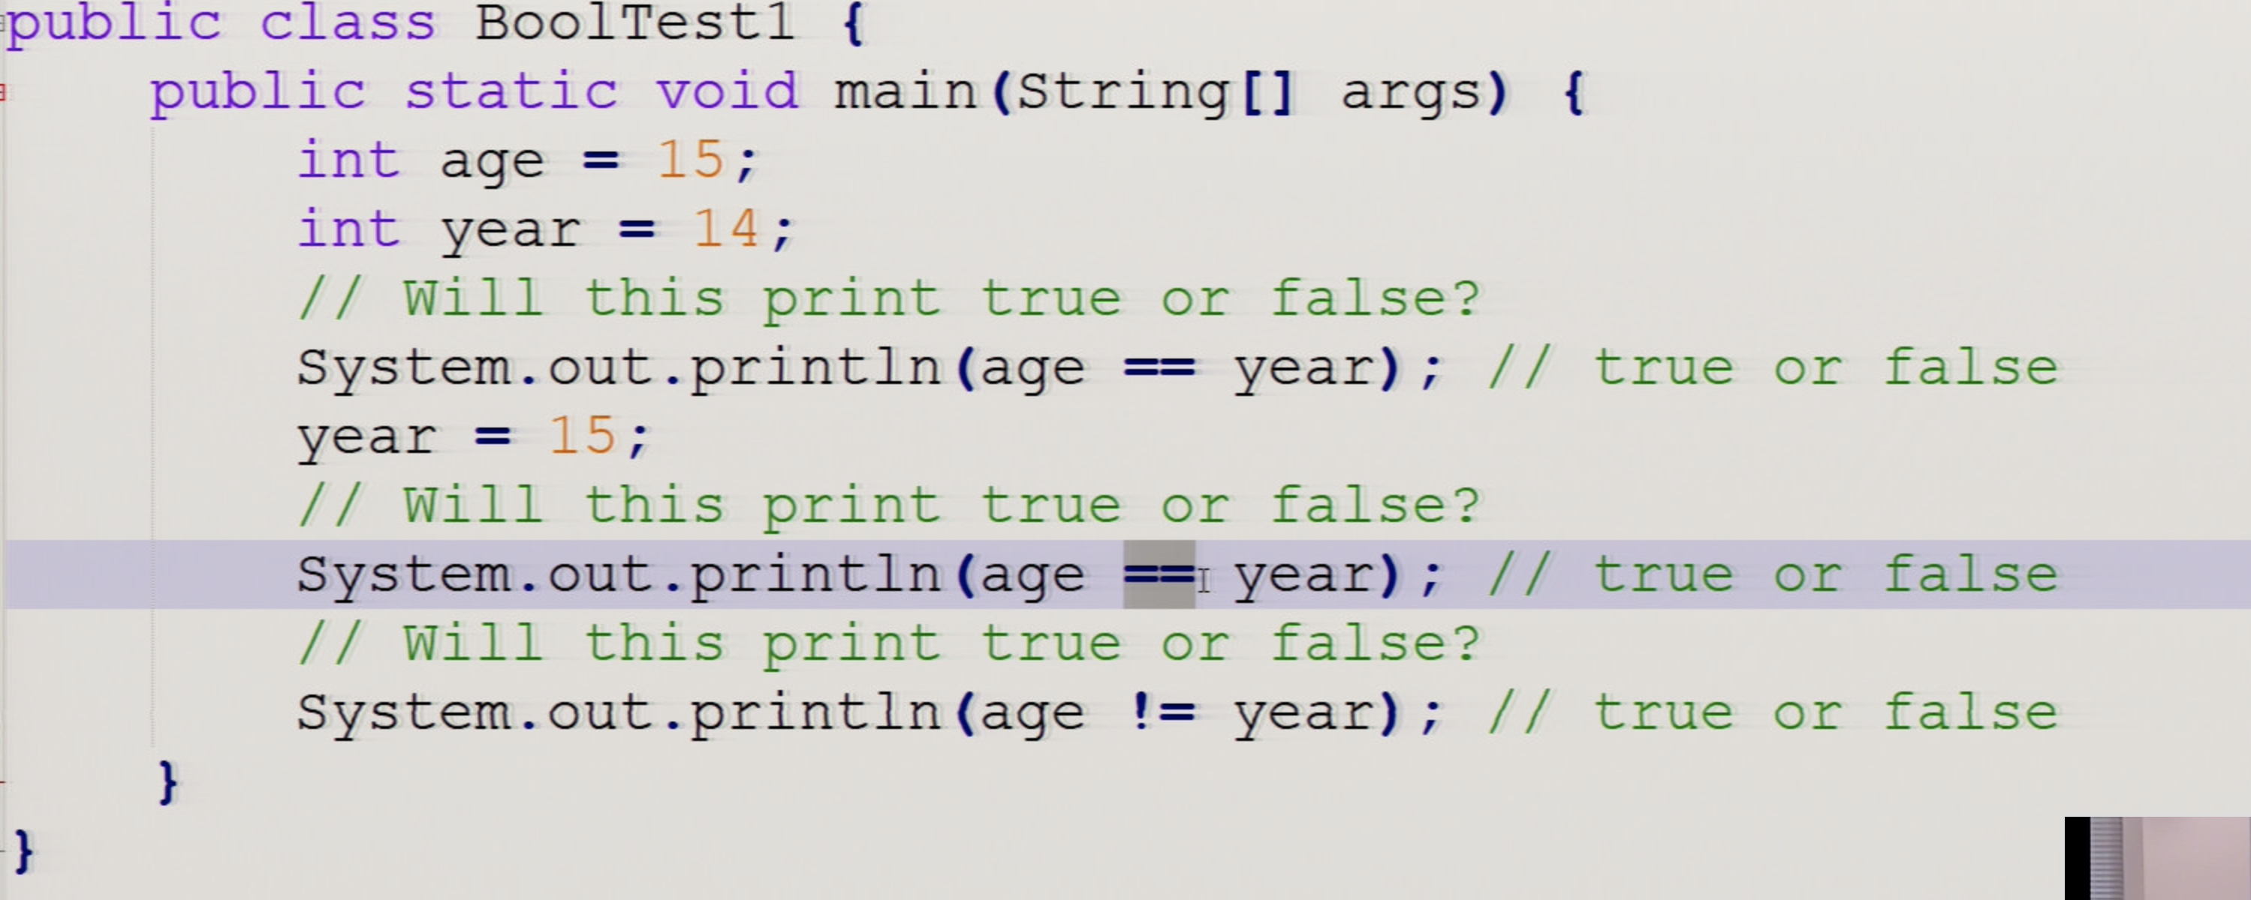
* Testing with mod (%)
* Relational Operators:

< >

<= >=

== !=  
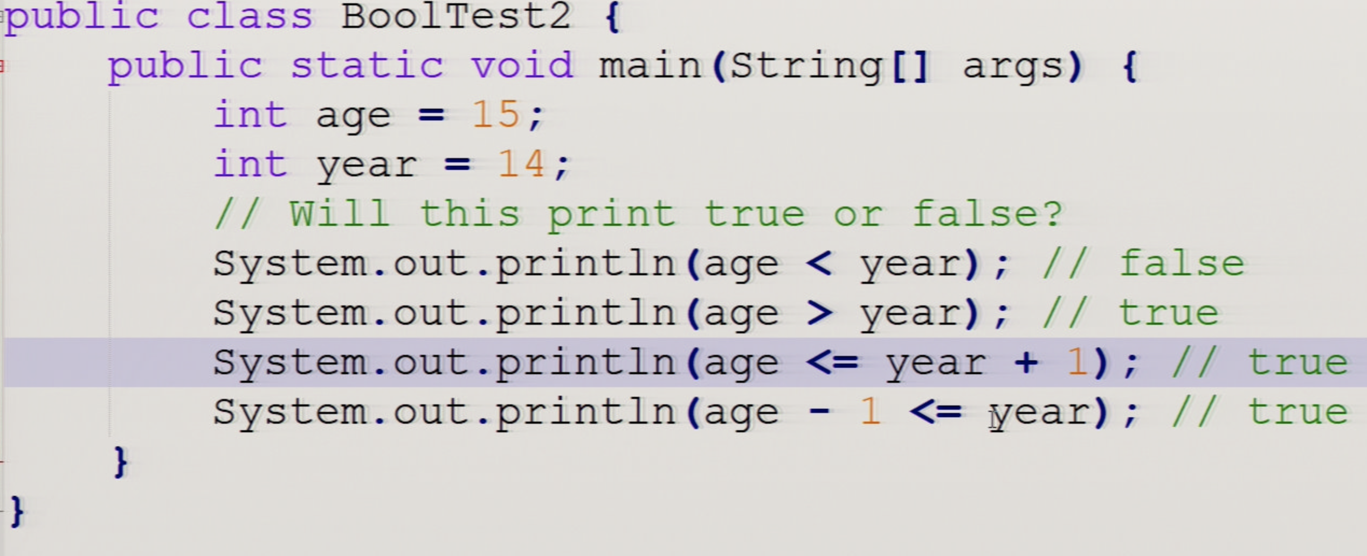

### **Summary**:

* Primitive values can be compared using relational operators (i.e., == and !=) in Java.
* Arithmetic expression values can be compared using relational operators. (i.e. <,>,<=,>=) in Java.
* An expression involving relational operators evaluates to a Boolean value of true or false.

### **If statements**

* If statements test a boolean expression and if it is true, go on to execute the following statement or block of statements surrounded by curly brackets {} like below.

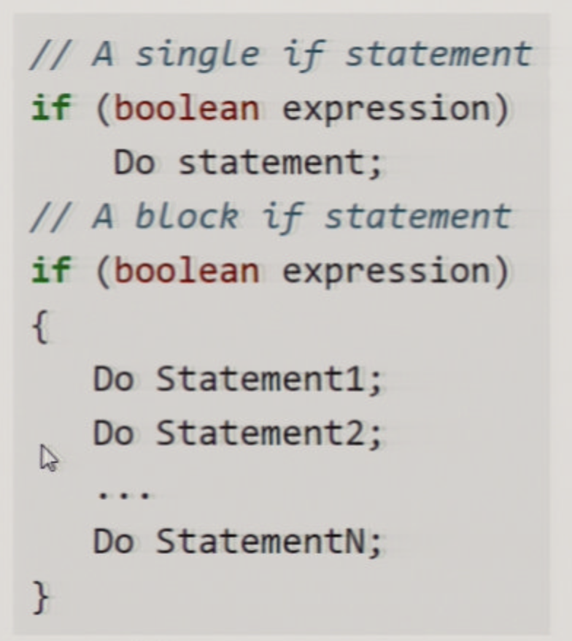 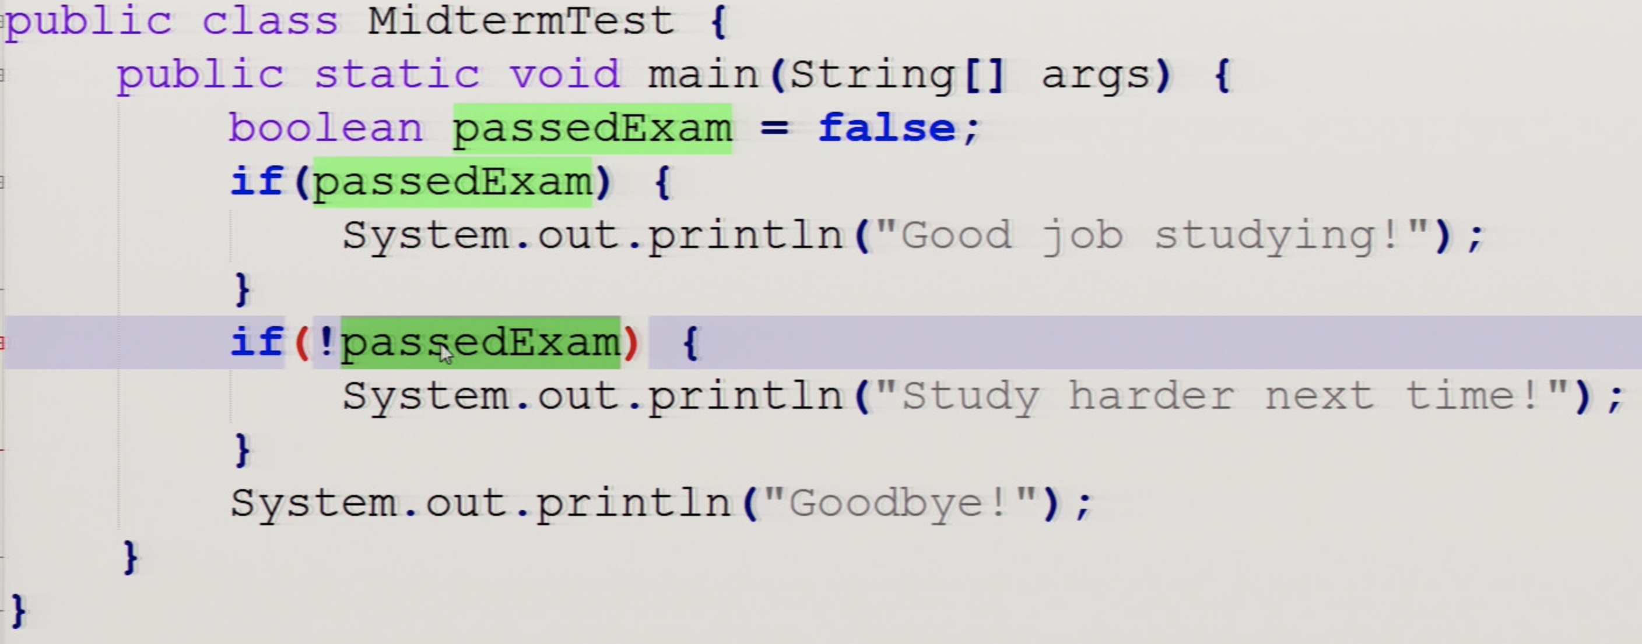  
== and !=

### **If-else statements**

* Nested ifs and Dangling Else
* If statements can be followed by an associated else part to form a 2-way branch:

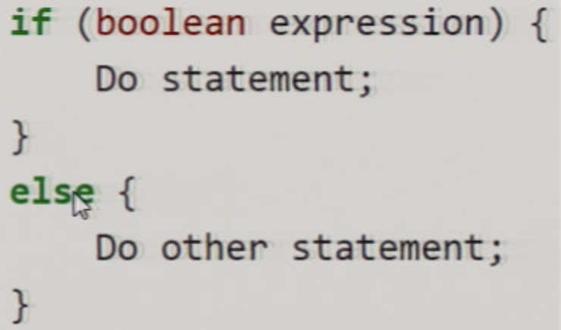 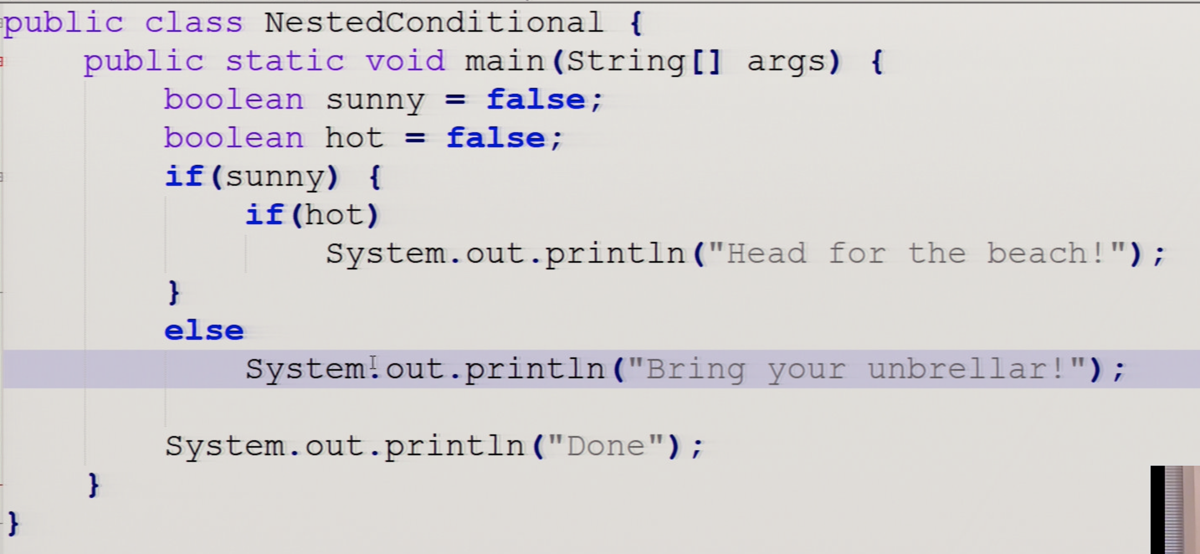

* A two-way selection (if/else) is written when there are two sets of statements.
* The body of the “if” statement is executed when the Boolean condition is true, and the body of the “else” statement is executed when the Boolean condition is false.
* The else statement attaches to the close st if statement.

### **Else-if statements**

* A multi-way selection is written when there are a series of conditions with different statements for each condition.
* Multi-way selection is performed using if-else-if statements such that exactly one section of code is executed based on the first condition that evaluates to true.

